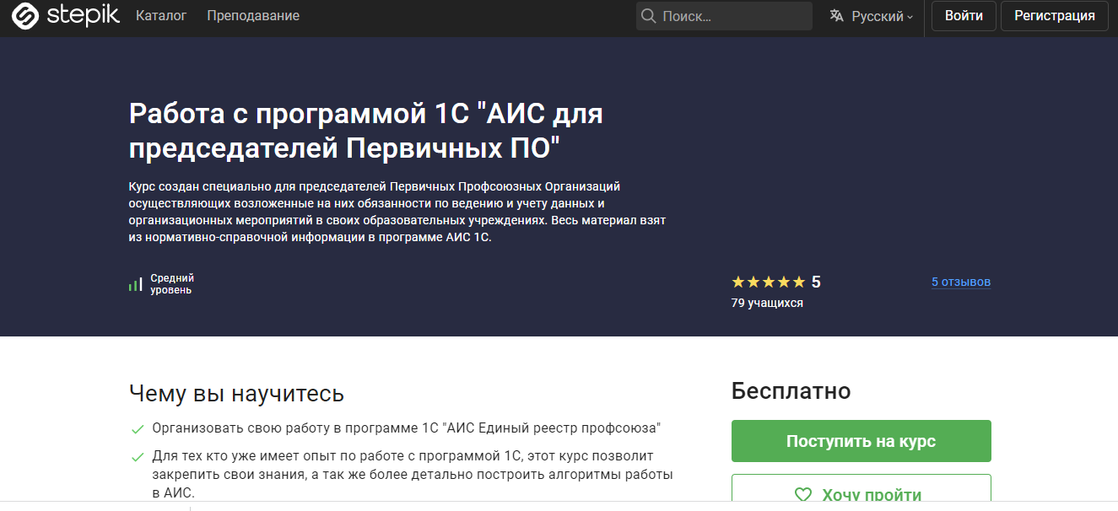

<https://stepik.org/course/123761/promo>